
Soft_Solutions4U
Quality System Procedure

Training Manual Template Volume 12 Version No. 1.2 Effective from 12 may
may 12 2010.



Trouble shooting on Screen Resolution Problem

Prepared By (SS4U) | Signature | R.MARIKKANNAN
Prepared By (SS4U) | Name | R.MARIKKANNAN
Reviewers | Signature
Reviewers | Name
Approvers | Signature
Approvers | Names

Soft_Solutions4U
Quality System Procedure

Training Manual Template Volume 12 Version No. 1.2 Effective from 12 may
may 12 2010.

Trouble shooting on Screen Resolution Problem

Problem:

The monitor is working perfectly on “Windows OS” but the same monitor isn't supported by the “Cent Os” and also “Ubuntu OS”.

Here we have “BenQ T52WA” monitor is working perfectly on “Windows OS” but the same monitor isn't supported by “Cent Os” and also “Ubuntu OS”.

In “Cent OS and Ubuntu OS” it will generate the error like “OUT OF RANGE”.

Solution:

First we collect the monitor details from “monitor acknowledgment card” or “Internet by using monitor name and monitor model number”.

Here we collect the monitor details like the following

Model Name : LCD Monitor – BenQ T52WA

Display Size : 1280 X 720 (default)

Horizontal Synchronization : 31.0 Hz – 64.0 Hz

Vertical Refresh : 56.0 Hz – 75.0 Hz

Soft_Solutions4U
Quality System Procedure

Training Manual Template Volume 12 Version No. 1.2 Effective from 12 may
may 12 2010.
Cent OS:

The GUI Mode is controlled by “X11 Server” in Cent OS. First you take backup on
configuration file of X11 server by using the command line.

To enter into command mode by “Alt+Ctrl+F1”.

To take X11 Server configuration file backup by using the following command

#cp /etc/X11/xorg.conf /etc/X11/xorg.conf.backup1 //rebuild purpose

After that set the monitor default value for monitor detection.

#system-config-display

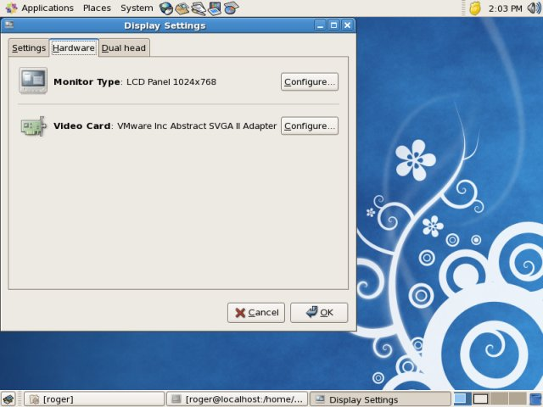
Soft_Solutions4U
Quality System Procedure

Training Manual Template Volume 12 Version No. 1.2 Effective from 12 may
may 12 2010.

Here you set the monitor default value in “settings”, you set default value like

Screen Resolution = 1280 X 720 //default

After that you reboot the system, now the monitor will work on GUI Mode
with default values.

Then you adjust the screen resolution value by

System----------->Preferences------------->Screen Resolution

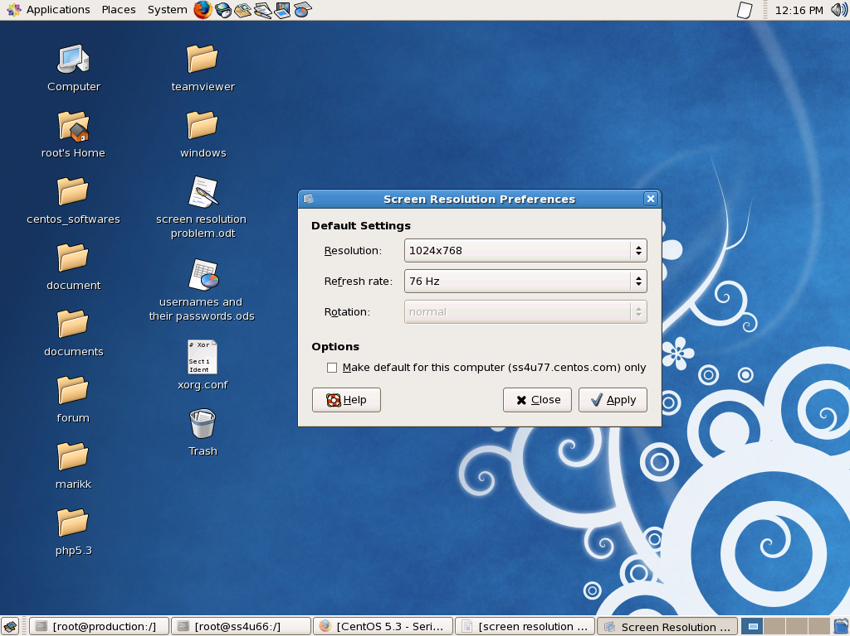
Now the monitor will work on Cent OS with 1024 X768 screen resolution.
Soft_Solutions4U
Quality System Procedure

Training Manual Template Volume 12 Version No. 1.2 Effective from 12 may
may 12 2010.

Ubuntu OS:

Go to command mode by using ( Alt+Ctrl+F1).

# xrandr -q
SZ: Pixels Physical Refresh
0 1024 x 768 ( 347mm x 260mm ) 76
1 800 x 600 ( 347mm x 260mm ) 73
2 640 x 480 ( 347mm x 260mm ) 73
3 640 x 400 ( 347mm x 260mm ) 0

It will display all possible screen resolution modes supported by monitor and that OS.

#xrandr -s 1024 X 768 //Set the Screen Resolution value.

Verify the Screen Resolution is set or not by

#xrandr -q

SZ: Pixels Physical Refresh
*0 1024 x 768 ( 347mm x 260mm ) *76
1 800 x 600 ( 347mm x 260mm ) 73
2 640 x 480 ( 347mm x 260mm ) 73
3 640 x 400 ( 347mm x 260mm ) 0

Reboot the system,now the Ubuntu OS will work on 1024 X 768 Screen Resolution.

